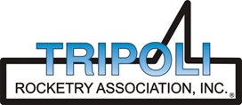
Tripoli Motor Testing Division
223 NC Highway 54 West
Chapel Hill, NC 27514
(919) 357 5681 (c)
May 9, 2022

Gary Rosenfield
RCS Rocket Motor Components, Inc.
2113 West 850 North Street
Cedar City, UT 84721

Dear Mr. Rosenfield,

The redesigned Aerotech M6000ST-P motor was tested on May 7, 2022 and is in compliance with NFPA 1125. The motor is certified for hobby rocketry use by the members of the Tripoli Rocketry Association and all approving organizations with reciprocal certifying agreements.

Motor Manufacturer Aerotech Division, RCS Rocket Motor Components
Manufacturer’s Designation M6000ST-P [98/10240 hardware]
Propellant Super Thunder
TMT Nomenclature 8247 M5959

Diameter 3.870” 98.3 mm
Overall Length 31.813” 808.04 mm
Length Inside 29.5” 749.3 mm
Length Outside 2.3125” 58.74 mm

Loaded Mass 17.7 lb 8028.58 g
Propellant Mass 8.527 lb* 3868 g*
Burnout Mass 9.02 lb 4091.4 g
* data provided by manufacturer

Burn time 1.382 sec

Total Impulse 1854 lbf.s 8247.1 N.s
Max Impulse 1526.2 lbf 6788.7 N
Average Impulse 1339.6 lbf 5958.9 N
Number of Motors Tested 3

Nominal Measured
Delay Time Data n.a. n.a.

Casing Temp. [NFPA 1125 7.4.1] Passed

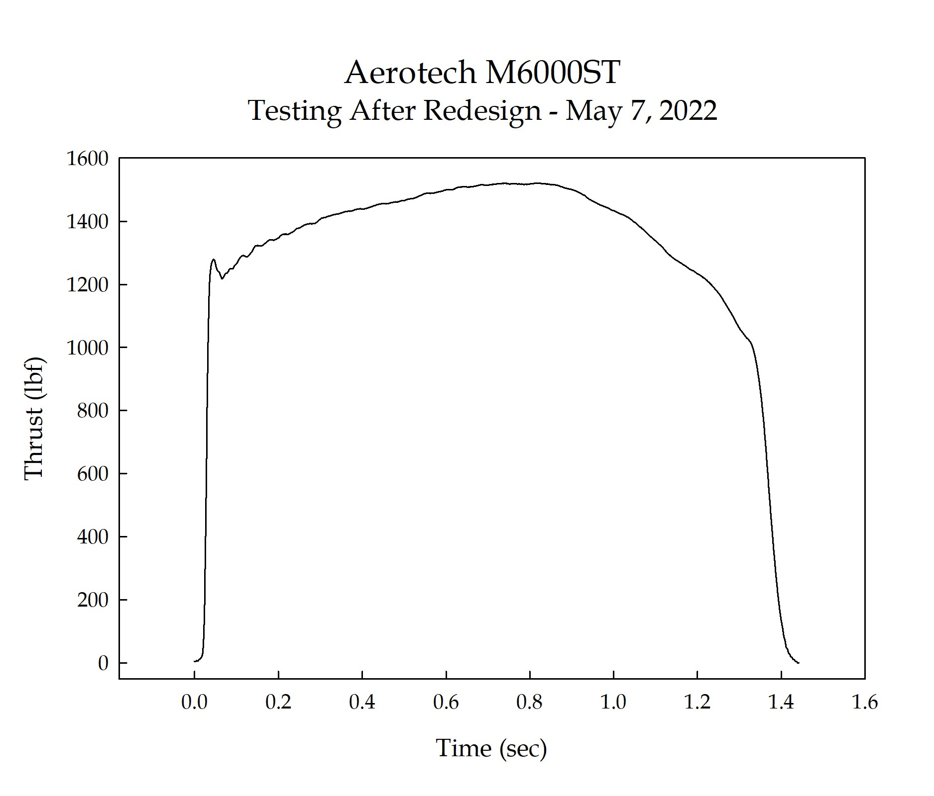

Sincerely,

Alan C. Whitmore
Chair, Tripoli Motor Testing

